**"QR-Code Based Attendance System"**

A MINOR PROJECTREPORT SUBMITTED TO

**THE NATIONAL INSTITUTE OF ENGINEERING, MYSURU**

(An Autonomous Institute under VTU, Belagavi)



In partial fulfillment of the requirements for Minor-Project work (CS6C06),   
sixth semester

**Bachelor of Engineering**

**in**

**Computer Science and Engineering**

*Submitted by*

**Sathkeerthi Y Agnihothri (4NI19CS099)**

**Shrivathsa Rao BV (4NI19CS104)**

**Vamshi M Jois (4NI19CS119)**

Under the Guidance of

Poornima N  
Assistant Professor

**DEPARTMENT OF COMPUTER SCIENCE AND ENGINEERING**

**THE NATIONAL INSTITUTE OF ENGINEERING**

Mysore-570 008

2021-2022

**DEPARTMENT OF COMPUTER SCIENCE AND ENGINEERING**

**THE NATIONAL INSTITUTE OF ENGINEERING**



***CERTIFICATE***

This is to certify that the project work entitled “**QR-Code Based Attendance System**” is a work carried out by **Sathkeerthi Y Agnihothri (4NI19CS099), Shrivathsa Rao BV (4NI19CS104) and Vamshi M Jois (4NI19CS119)** in partial fulfillment for the minor-project work (CS6C06), sixth semester, Computer Science & Engineering, The National Institute of Engineering **(**Autonomous Institution under Visvesvaraya Technological University, Belagavi) during the academic year 2021-2022. It is certified that all corrections and suggestions indicated for the Internal Assessment have been incorporated in the report deposited in the department library. The minor project work report has been approved in partial fulfillment as per academic regulations of The National Institute of Engineering, Mysuru.

**Signature of the Internal Guides** **Signature of the HoD**

**______________ _______________**

Poornima N  
Assistant Professor

Dr. C Vidya Raj  
Professor and Head  
Dept. of CS&E  
NIE, Mysuru

**ACKNOWLEDGEMENT**

It is our privilege to express gratitude to all those who inspired us and guided to complete the Minor Project. This minor project work has been accomplished only with the direct or indirect help of many people who have guided us. We’re grateful to them.

We wish to express my gratitude to Dr. NV Raghavendra, Principal, NIE, for his encouragement and support.

We also express our deepest gratitude to Dr. C Vidya Raj, Professor & HOD, Department of Computer Science and Engineering, NIE, Mysuru, for her profound alacrity in our progress and her constant guidance and encouragement.

We would take this opportunity to express our sincere thanks to guide Poornima N, Assistant Professor, Department of Computer Science and Engineering, NIE, for her constant guidance and encouragement.

We would like to thank all our Professors and Faculty Members of NIE, Mysuru for their suggestions, encouragement, and support.

**- Sathkeerthi Y Agnihothri**

**-Shrivathsa Rao BV**

**- Vamshi M Jois**

**Table of Contents**

**Contents** **Page**

**Chapter 1** - **Introduction**…………………………………….……………………………….. .1

1.1QR Code Structure……………………………………………………………………… 1

1.2 What is QR Code? ...................................................................................................................1

1.3 How is QR Code Structured? ……………………………………………………………....2

1.4 Difference between OR Code and Bar Code………………………………………………..2

1.5 Aims of the project……………………………………………….. ………………………..2

**Chapter 2** – **System Analysis**…………………………………………………………………...3

2.1 Existing System……………………………………………………………………………..3

2.2 Drawbacks of Existing System……………………………………………………………...3

2.3 Proposed System……………………………………………………………………………4

2.4 Features of Proposed System………………………………………………………………..4

2.5 System Requirements…………………………………………………………………….....4

**Chapter 3** - **System Design**……………………………………………………………………..5

**Chapter 4** - **System Implementation**……………………………………………………….…..7

4.1 Working of the Project………………………………………………………………….…..7

**Chapter 5 -** **System Testing**………………………………………………………………..….12

**Chapter 6** – **Results**………………………………………………………………………...….14

6.1 Conclusion and future Enhancements…………………………………………………...….17

**References**……………………………………………………………………………..….18

**List of Figures**

|  |  |  |
| --- | --- | --- |
| **Figure No.** | **Description** | **Page** |
| fig:1.1 | QR Code Structure | 1 |
| fig3.1 | Flow Chart | 5 |
| Fig4.1 | Requirements/Modules needed to install | 7 |
| Fig4.3 | QR Code Illustration | 9 |
| Fig4.4 | Activating the Scanning of the QR Code | 9 |
| Fig4.5 | The Graphical User Interface | 10 |
| Fig4.6 | Options in year field | 10 |
| Fig4.7 | Options in branch field | 11 |
| Fig4.8 | Options in section field | 11 |
| Fig4.9 | Options in period field | 11 |
| Fig5.1 | List of students for which QR Code need to be generated | 12 |
| Fig5.2 | List of students for which QR Code is generated | 12 |
| Fig5.3 | Representation of QR Code for Students | 13 |
| Fig6.1 | Filling in mandatory parameters in GUI | 14 |
| Fig6.2 | Frame activated on submit, ready to scan QR Codes | 14 |
| Fig6.3 | Scanning of registered QR Codes | 15 |
| Fig6.4 | Excel Report generated | 16 |

**Chapter 1**

**Introduction**

This project aims to use technology to the fullest to make it ease and to reduce the errors in the process of "Attendance". QR-code based attendance system is an attempt to automate the process of attendance. It uses computer webcam to scan for QR codes, where based on its authentication and validation algorithm, decides to either record or ignore the decoded data.

It is a cost efficient, yet fully functional method of attendance automation which integrates as front interface for monitoring and recording.

It features time-bound attendance monitor, attendee QR code generator, schedule generator, ability to configure record exporter in the form of MS excel or Google sheets (.xlsx) format. This .xlsx file can be uploaded to the mainstream website/application to directly import the daily attendance to a database to maintain accurate records of the college student attendances.

QR CODE STRUCTURE:

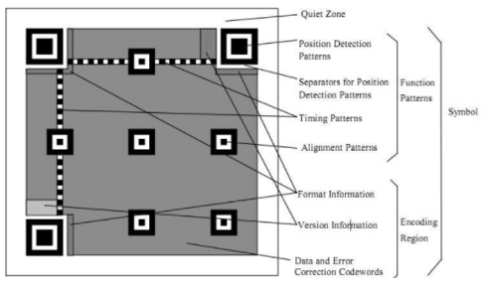

Fig:1.1

What is a QR Code?

The QR Code is a two-dimensional version of the barcode, known from product packaging in the supermarket. Originally developed for process optimization in the logistics of the automotive industry, the QR Code has found its way into mobile marketing with the widespread adoption of smartphones. "QR" stands for "Quick Response", which refers to the instant access to the information hidden in the Code. QR Codes are gaining popularity because the technology is "open source", i.e. available for everyone. Significant advantages of QR Codes over conventional barcodes are larger data capacity and high fault tolerance.

How is a QR Code structured?

The black and white checkered pixel patterns appear at first glance to be a small crossword puzzle and seem to be composed at random. But if you look closely, certain structures can be identified. For the scanner to recognize a QR Code as such, the Code must always be square. A number of additional elements ensure that the information is read correctly. Each part of the two-dimensional code has its own function, and can basically be divided into two parts: functional patterns and encoding region.

QR codes vs. Barcodes – Differences and advantages of QR codes

A QR code is a matrix type 2D barcode (also known as checkerboard type 2D barcode), which has been frequently used on mobile devices in recent years. Compared with traditional barcodes, it can store more information.

A two-dimensional code uses a certain geometric figure to record data symbol information in a black and white pattern distributed on a plane (two-dimensional direction) according to a certain rule. It can record numbers, English letters, Chinese characters, Japanese letters, special symbols (such as spaces, %, / etc.), binary information and other information into a square picture. In the position of the corresponding element of the matrix, the appearance of dots (square dots, dots, or other shapes) is used to represent binary “1”, and the absence of dots represents binary “0”. The permutation and combination of points determine the meaning of the matrix two-dimensional bar code.

AIMS OF THE PROJECT:

The main aim of this project is to computerize the attendance system and reduce time consumption. This project has the following objectives: -

1. To develop a QR code generator using Python
2. To develop an Attendance Management System which scans the QR codes and marks attendances

**Chapter 2**

**System Analysis**

EXISTING SYSTEM:

In a classroom, the lecturer usually takes attendance each session. Taking attendance requires about 5 to 10 minutes, not to mention the chaos that usually happens in the meantime. Attendance is taken in daily basis by manually on the register and at the end of the month or so, is uploaded to the Contineo student portal.

DRAWBACKS OF EXISTING SYSTEM:

1. Lots of paperwork: Existing system requires lot of paperwork. Loss of even a single register/record leads to difficult situation because all the papers are needed to maintain actual factual records, in case of any emergency. Also, papers are not the best in terms of durability, and are subject to corrosion by lots of means, ink used to mark attendance can get erased due to water, etc.
2. Time consuming: Every period, attendance is taken mid-session, so valuable time which could otherwise be completely used for lecturing is lost in this unproductive activity, and distraction from study-mode alike.
3. Low flexibility: If some student comes to the class a few seconds/minutes later of marking of the attendance, and the lecturer has already taken the attendance at the beginning of the class, then he has to again open the register for a single student and changing status from “Absent” to “Present” spoils the cleanliness.
4. Time-bound monitoring is not possible: Existing system doesn’t mark the check-in time of student, thus less accurate, and you can’t provide attendances based on time spent in classroom in that lecture.
5. Double work: Attendance is taken in manual registers and later uploaded in the Contineo student portal, which is twice the work for lecturers.
6. Subject to mistakes: Since it is a work manually done by humans, it can always have many mistakes, which can often lead to difficulties for the students, and rarely but not never – to the educational institution as well.
7. Difficulty to organize: There is no fast methods to sort, find or edit any entry, and not to mention, it takes up a lot of space.

PROPOSED SYSTEM:

The proposed system uses QR-code method for authenticating students with a unique QR-code that represents their unique ID. Every student is provided with a card that contains the QR-code. Students are supposed to scan their QR code before the period begins.

FEATURES OF PROPOSED SYSTEM:

* GUI mini interface is used before scanning QR Codes, setting class, branch and other parameters.
* Until and unless all the fields are filled, the QR code scanning doesn’t open up scanning of QR codes.
* The QR code is a two-dimensional code which has black squares arranged on a white background which efficiently stores data.
* A QR code can be embedded anywhere, here it is embedded on the ID card.
* The QR code could be scanned by camera or QR code Scanner.
* QR codes are unique, so it differs from one student to other.
* After Scanning the QR code the system will generate a report (.xlsx file) when the scanning session is closed, that contains the names of the present, along with their class info and check-in time.
* The excel file is named to the date at which the report was generated by default.
* This report will later be uploaded into a college attendance management portal similar to Contineo (not included in the project), which will add the data into respective tables with regard to the information in the columns of the report.

SYSTEM REQUIREMENTS:

* QR code scanner / laptop with webcam
* Processors: Intel Atom® processor or Intel® Core™ i3 processor
* Disk space: 1 GB
* Operating systems: Windows 7 or later, macOS, and Linux
* Python versions: 2.7.X, 3.6.X
* Python modules: MyQR, TKinter(tk, tk-tools), pyzbar, CV2 (opencv-python)

**Chapter 3**

**System Design**

The system is really easy to understand, and the main software used is Python, along with different modules that help us to perform tasks to achieve project aim.

The project has totally 2 phases / parts as discussed:

1. Generation of QR codes of students as one-time operation
2. Scanning of QR codes for marking attendance, and generating report

FLOWCHART

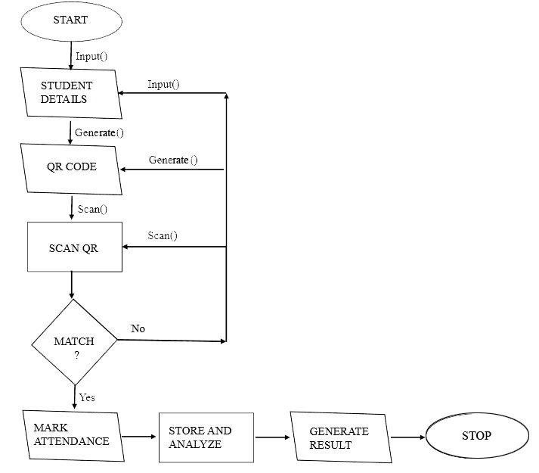Fig:3.1

* At the beginning of the stage, Student names (and other unique markers for student) are entered into the ‘studentslist.txt’ file. This data is imported in the QR code generation phase unique to the data entered.
* The generator recognizes newline character as delimiter and generates QR code for data between the newline characters. The QR codes are saved as the data entered and found in the students list file, which are imprinted on ID cards and handed over to respective students.  
  The QR code generation phase uses mainly the Python module called ‘MyQR’, that converts every data into its QR code, thus unique for every unique data.
* In the second phase, GUI is filled with the parameters and readied for scanning the QR codes, which then scans the codes.
* If the value of decoded QR code is not present in the studentslist.txt file, then it again gets ready to scan another QR code.
* Else if it is present in the studentslist.txt file, then Attendance for that student is marked in the excel sheet, and the system time is marked as his check-in time.
* This procedure is done until the frame takes an input of ‘G’ through the standard input (keyboard), which terminates the scanning and closes the frame.
* The final report is generated in .xlsx format, and system comes to stop.

.

**Chapter 4**

**System Implementation**

The project is completely made out of Python and external Python modules, thus making the system less complex in terms of software requirements. It also needs only a webcam as an additional hardware, which is extremely common and embedded into every laptop nowadays.

**Working of the project**

1. Requirements / Modules needed to install

Fig:4.1

**MyQR**:

* This module is a QR code generator and can generate common qr-code, artistic qr-code (black & white or colorized), animated qr-code (black & white or colorized).
* The module automates most of the building process for creating QR codes.
* This module attempts to follow the QR code standard as closely as possible.

**Tkinter:**

Tkinter is the standard GUI library for Python. Python when combined with Tkinter provides a fast and easy way to create GUI applications. Tkinter provides a powerful object-oriented interface to the Tk GUI toolkit.

Creating a GUI application using Tkinter is an easy task, and that is the reason we have completely depended on Tkinter to build our GUI for the system.

**Pyzbar:**

* The pyzbar module is a module that is responsible for reading and decoding 1-D barcodes or QR codes easily.
* In order to extract information from an image of a QR code is obtained with the help of decode function which takes the image object as a parameter.

**cv2:**

* CV2 is nothing but the latest version of opencv.
* Opencv is a library of programming functions mainly aimed at real-time computer vision. In simple language it is a library used for Image Processing. It is mainly used to do all the operation related to images.
* OpenCV helps in manipulation of images. Like read an image, write an image, convert colored to gray, binary, HSV etc.

1. Generating QR codes in cmd

Fig:4.2

Command prompt is opened in the directory where the files are saved, and command ‘python Generate.py’ is entered. This will read the students list text file and create unique QR codes for every student in the list.

These QR codes are handed over to the students by imprinting them on the ID card for them to scan every time before a period starts.

1. QR code illustration for a student

Unique QR code of a student named Carl Johnson

Fig:4.3

1. Activating the scanning of QR codes

Fig:4.4

To start the scanning process of student QR codes, this Python command ‘python Attend.py’ is entered in the directory of the project files, which opens up the GUI.

1. The Graphical User Interface

Completely built using tkinter – a Python module, it is simple and minimalistic GUI that makes the system much more interactive and interesting.

It contains important properties by which attendances are going to be filtered, and also the information that is needed essentially, like the Year of study, Branch of Engineering, Section, and the Period of the day

Fig:4.5

1. Options in Year field

Fig:4.6

1. Options in Branch field

Fig:4.7

1. Options in Section field

Fig:4.8

1. Options in Period field

Fig:4.9

**Chapter 5**

**System Testing**

1. List of students for which QR codes need to be generated

Fig:5.1

1. Generating QR codes for the students

Fig:5.2

1. QR codes of students

Fig:5.3

**Chapter 6**

**Results**

1. Filling in the parameters in GUI

Fig:6.1

All parameters in the GUI are mandatory, and are filled before the class starts, so that the scanner frame activates.

1. Frame activated on submit, ready to scan QR codes

Fig:6.2

Any status of the frame scanning is displayed in the command prompt that calls the ‘Attend.py’ file.

1. Scanning of registered QR codes

Fig:6.3

If any QR code that is already marked present is again being scanned, it shows “Already Present” in the command prompt.

Also, any QR code that is not registered in the system will not be scanned at all.

To terminate the scanning and close the frame, you need to press the “G” key on the keyboard, or else the frame keeps on opening if clicked on the top-right cross button.

1. Excel (.xlsx) report of the students with all the relevant information

* Generated report will be named as the date of the scanning of QR codes.
* Report will contain the columns of Student name, Branch and section, year of engineering, period for which the attendance was taken, and the check-in time of the students.

Fig:6.4

This report can later be imported into the college attendance management system, that will filter the reports’ parameters and store attendance in respective tables of the database.

**Conclusion and Future Enhancements**

The working model aims to improvise the existing system by a ton and improve quality of life. This is a cost efficient, yet fully functional method of attendance automation which integrates as front interface for monitoring and recording.

Accurate time-bound attendance generation in easily modifiable and effortlessly convertible Excel sheet format is highly desirable, and readily importable into college attendance management system, that makes it a must have in technically forward institutions.

FUTURE ENHANCEMENT IDEAS:

The whole College student portal, that accepts the report and mark attendance in the database will complete this whole project.

This system, if not too cautious can lead to lots of proxies in the attendance, as a student can handover his QR code to his friend, who can get it scanned while he scans his code. In combination with a facial recognition system, this attendance taking method will be fool proof.

Furthermore, this system can be completely modified so that a faculty gets new QR codes every session, and students have to scan it from their phones through a web/app interface, which marks the student as present. Since no one will be foolish enough to handover their phones to a classmate, proxy becomes unattainable.

**References**

* Learning Python, Mark Lutz, O’Reilly Media, 5th Ed.
* Official Python Documentation: [https://docs.python.org](https://docs.python.org/)
* YouTube: [https://www.youtube.com](https://www.youtube.com/)
* Full Stack Python: <https://www.fullstackpython.com>
* Stack Overflow: [https://stackoverflow.com](https://stackoverflow.com/)